Excel metadata capture instructions

The spreadsheets for capturing the experimental data are both .xlsm files, this refers to macro enabled excel files. Make sure to enable macros when prompted, or you won’t be able to use the helpful buttons on the spreadsheet!

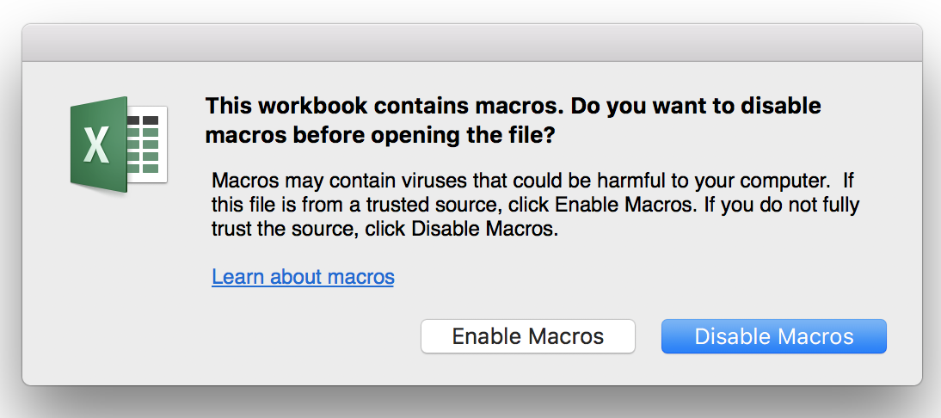

Before you start filling in the template with your experimental details make sure you have your settings sheet filled in.

# Settings.xlsm sheet

This sheet holds the table with all your subject details, or will once you fill it in, these will automatically get pulled when you select a subject on your subject details sheet.

Here are instructions on how to add a subject to the cohort list:

Open the settings.xlsm file, make sure to enable macros when prompted, click the Add New Line to Cohort Details button.

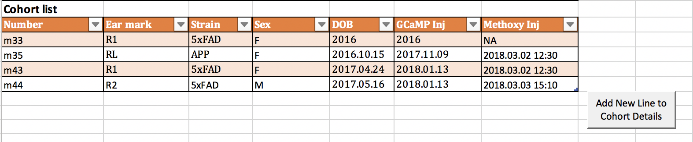

This adds an empty row to the cohort list table.

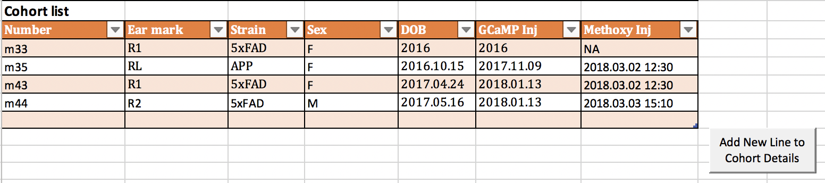

Fill this in with the new subject details

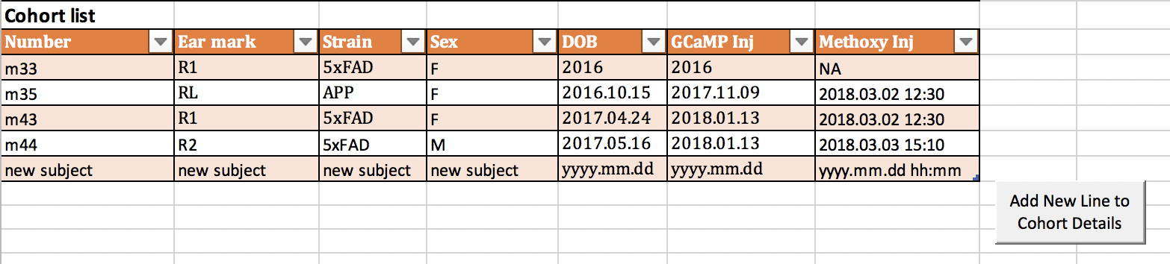

If you now check the template.xlsm spreadsheet you will be able to see that our new subject has been added to the Number drop down list.

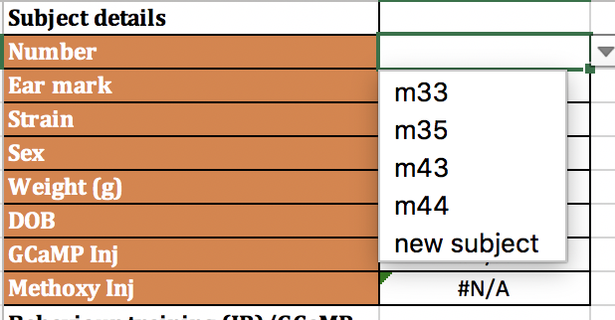

(Screenshot from the template.xlsm spreadsheet)

Selecting this subject auto fills the other cells with the data from the Cohort table in the settings.xlsm spreadsheet.

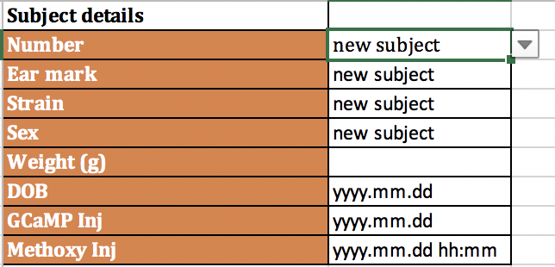

# Template Experiment Data Sheet.xlsm

Experiment Details sheet:

Fill in the details of the experiment

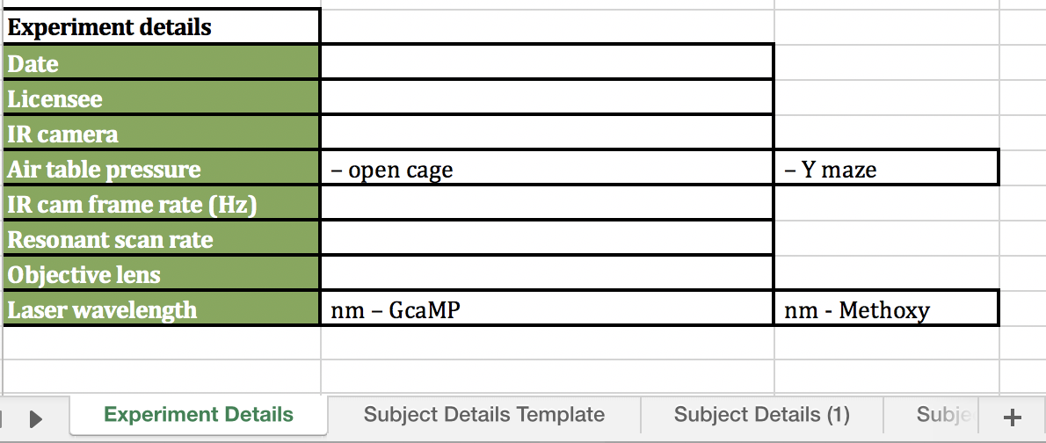

Subject Details Template sheet:

The subject details are auto filled when the subject number is selected from the drop-down list.

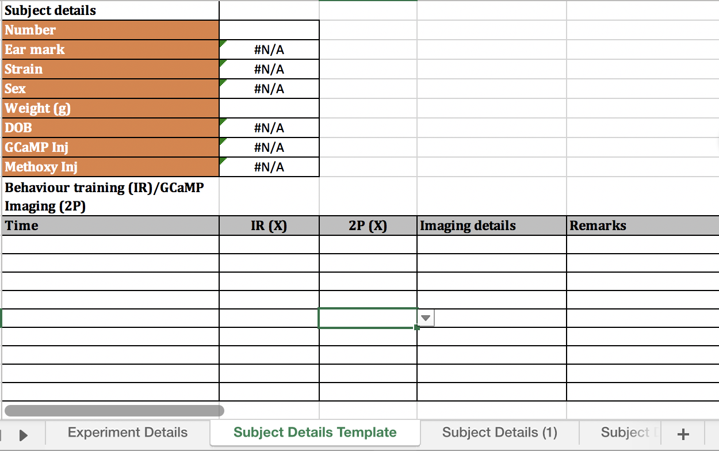

The time values are entered in each row and X’s selected if there is an IR session or 2P session, imaging details and other remarks are entered into the columns.

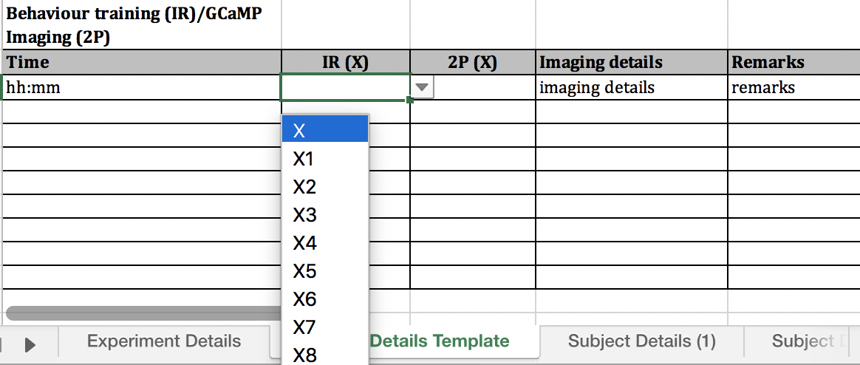

# Making copies of subject details template sheet

When making a new subject details sheet right click on the Subject Details Template sheet and select Move or Copy…

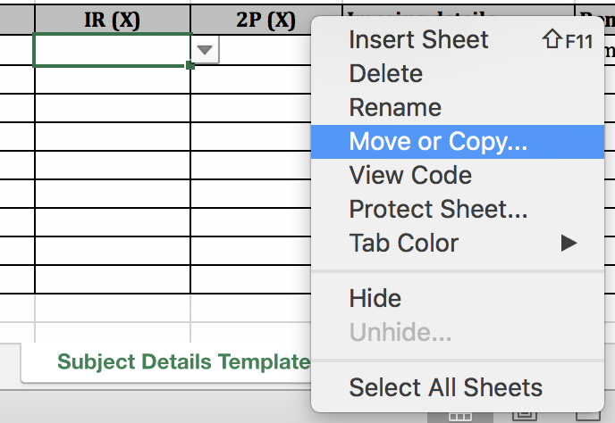

This opens a list of the sheets in the workbook, select Subject Details Template and tick Create a copy

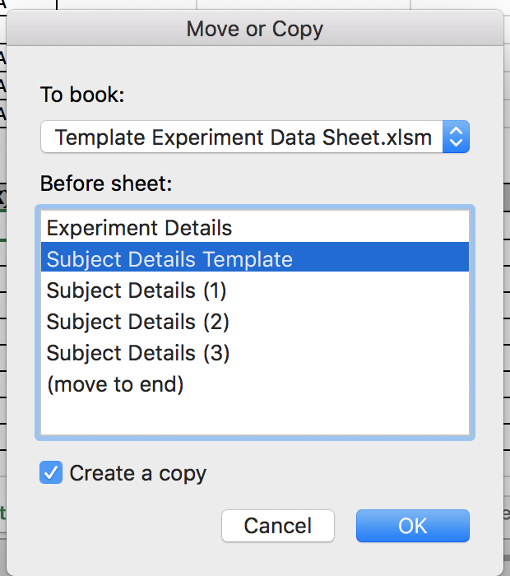

This creates a copy of the Subject Details Template, rename this sheet, by right clicking on the sheet and selecting rename. To either Subject Details (?), with the ? corresponding to the next Subject Details or to the subject name beginning with m, eg m45.

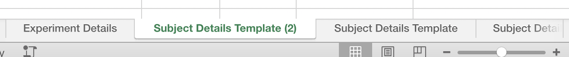

Then drag this sheet to the end to organise the sheets.

Details on macros

The macros need to be lined up with the bottom of the table for which they are adding a row, these should not be moved or the way the macro adds new lines will be disrupted.

Do not change the naming or structure of the template as this will disrupt the variables that are extracted for the NeuroSEE pipeline, if you need to make changes to adapt the template to your work structure please make a copy of it for editing.

If using an edited template to build NWB Files make sure that the NWB variables match up, as the variable extraction relies on row and column indexing, open the created Excel file using Python Pandas and check if the variables are being correctly extracted.